Visual Overview (Mindmap)
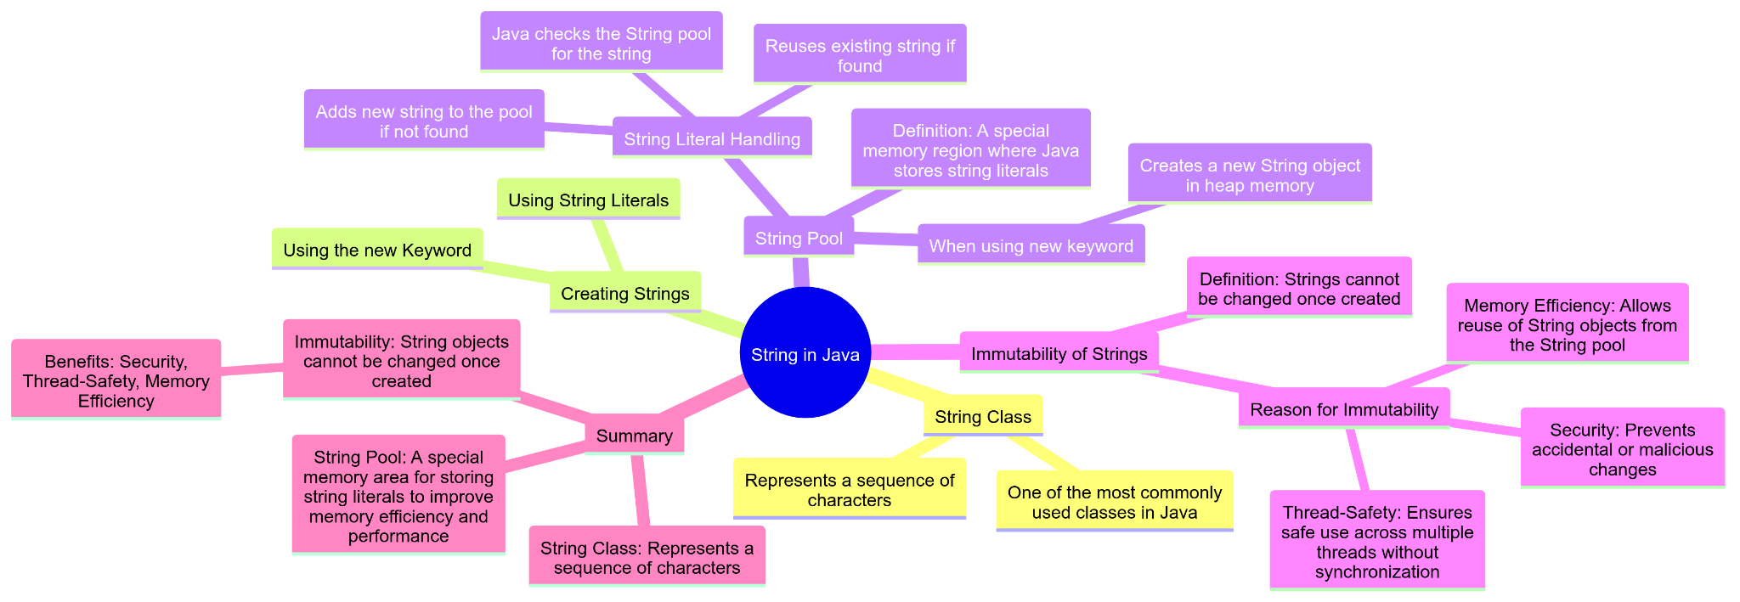

String in Java
- String Class: In Java, String is a class that represents a sequence of characters. It's one of the most commonly used classes in Java.
- Creating Strings: You can create String objects in two ways:

1. Using String Literals:
String s1 = "Hello";
Stack and heap

[Stack : s1] -> [ Heap [String pool -> “Hello”]]
String s2 = "Hello";

[Stack : s1] -> [ Heap [String pool -> “Hello”]]
s2 ->
[2. Using the new Keyword:
String s3 = new String("Hello");
[Stack s3 -> [ “hello” in the heap]

String Pool
- Definition: The String pool (or intern pool) is a special memory region where Java stores string literals.
- String Literal Handling:
  - When you create a string using a literal (e.g., String s1 = "Hello";), Java checks the String pool to see if the string already exists. If it does, it reuses the existing string. If not, it adds the new string to the pool.
  - String s2 = "Hello";
  - When you create a string using the new keyword (e.g., String s2 = new String("Hello");), it creates a new String object in the heap memory, even if an identical string exists in the String pool.

Example:
String s1 = "Hello";
String s2 = "Hello";
String s3 = new String("Hello");

System.out.println(s1 == s2); // true, both refer to the same object in the String pool
System.out.println(s1 == s3); // false, s3 refers to a new object in the heap

Immutability of Strings
- Definition: Strings in Java are immutable, meaning once a String object is created, it cannot be changed.
- Reason for Immutability:
  - Security: Prevents accidental or malicious changes.
  - Thread-Safety: Ensures safe use across multiple threads without synchronization.
  - Memory Efficiency: Allows reuse of String objects from the String pool.

Example:
String s1 = "Hello";
s1 = "World"; // This creates a new String object and s1 now refers to "World"

String s2 = "Hello";
s2.toUpperCase(); // This doesn't change s2, it creates a new String object

System.out.println(s1); // Outputs "World"
System.out.println(s2); // Outputs "Hello"

In the example above, when s1 is reassigned to "World", a new String object is created and s1 now refers to this new object. The original "Hello" string remains unchanged. When toUpperCase is called on s2, it returns a new String object ("HELLO") but does not change the original s2.

Summary
- String Class: Represents a sequence of characters.
- String Pool: A special memory area for storing string literals to improve memory efficiency and performance.
- Immutability: String objects cannot be changed once created, which provides benefits like security, thread-safety, and memory efficiency.

Prepared by : Rishi patel

